**Reaction Quotient**

The reaction quotient (Q) measures the relative amounts of products and reactants present during a reaction at any particular point in time.

The value of Q, can be determined if the concentrations of the reactants and products are known.

For a given general chemical equation:

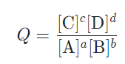The Q equation can be written by multiplying concentrations for the products and dividing by the concentrations of the reactants. If any component in the reaction has a coefficient, indicated above with lower case letters, the concentration is raised to the power of the coefficient.

**Note**

* This equation only shows components in the gaseous or aqueous states.
* Pure liquids or solid are given the value of one (1).
* Since it is a ratio, there are no units.
* 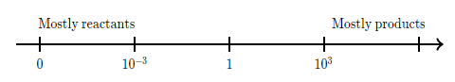Q can have possible values starting from zero—all reactants—to infinitely large—all products.

**Example One**

The following equation shows the reaction between carbon monoxide and water vapour.

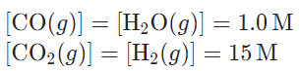

**TIP**

Since we have calculated the value of Q using concentrations the symbol is often changed to

Qc

1. 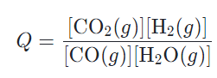Write the equation for the reaction quotient?
2. Calculate the value of the reaction quotient.

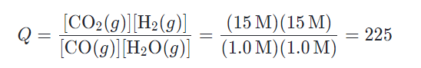

**Example Two**

The following equation shows the reaction of nitrogen with hydrogen to produce ammonia (commonly referred to as the Haber process).

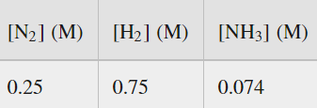

1. 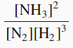Write the equation for the reaction quotient?

Qc =

1. Calculate the value of the reaction quotient.



Learn to use brackets correctly

In this case, if you do not use brackets, the calculation may give you an incorrect answer

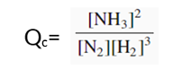

= 0.0742 / (0.25 x 0.753) = 0.052

**Equilibrium Constant**

* The value of Q at equilibrium is referred to as the Equilibrium Constant (K).
* The equilibrium constant is the ratio of reagents and products at equilibrium.
* At any specific temperature, the value of K is a constant (does not change), hence the name equilibrium constant.
* Both Q and K are usually calculated using reagent and product concentrations. A “c” is added to indicate that concentrations were used, for example, Qc or Kc

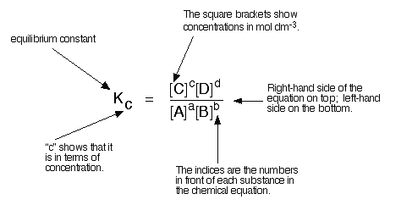

* Reaction and equilibrium constants can also be calculated using partial pressures in a gaseous system. In this case a small “p” would be used, for example Qp or Kp.